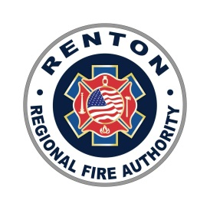 | RFA CIVIL SERVICE COMMISSION REGULAR MEETING AGENDA  4:00 P.M. – December 20, 2022, Conference Room A or Virtually via Zoom  View Live via Facebook: http://www.Facebook.com/RentonRFA

- Call Regular Meeting to Order

- Review and Approval of Minutes

  - November 15, 2022 regular meeting minutes*

- Public Comment
Members of the audience may comment on items relating to any matter related to RFA business
under the Public Comment period. Comments are limited to three (3) minutes per person
  - Unfinished Business
  - NA
- New Business
  - Deputy Fire Chief Eligibility List Certification*
- Other Business
  - Next Regular meeting is January 17, 2023**
  - Academy Graduation (7 recruits) January 12 @6pm**

- Adjournment

*Requires Commission Action
**Informational Only

