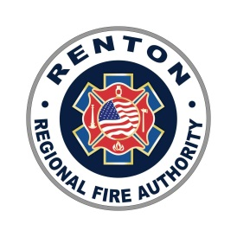 | RFA CIVIL SERVICE COMMISSION REGULAR MEETING AGENDA  4:00 P.M. – November 15, 2022, Conference Room A or Virtually via Zoom  View Live via Facebook: http://www.Facebook.com/RentonRFA

- Call Regular Meeting to Order

- Review and Approval of Minutes

  - October 26, 2022 regular meeting minutes*

- Public Comment
Members of the audience may comment on items relating to any matter related to RFA business
under the Public Comment period. Comments are limited to three (3) minutes per person

  - Unfinished Business
  - Proposed Civil Service Rule Change*
    - Rule 12.02 Length of Probationary Period (new hire firefighters)
  - Proposed Civil Service Rule Change*
    - Rule 10.05 Duration of Eligibility Lists (Promotional List)

- New Business
  - Deputy Fire Marshal I Job Description*
  - Deputy Fire Marshal II Job Description*
  - Probationary Termination*
    - Rule 16.09 Consent of Commission
  - Captain Bypass on Eligibility List**

- Other Business

  - Next Regular meeting is December 20, 2022**

- Adjournment

*Requires Commission Action
**Informational Only

